# Subnet Masking:

1. Fixed Length Subnet Masking (FLSM)
2. Variable Length Subnet Masking (VLSM)

# Classes of IPV4

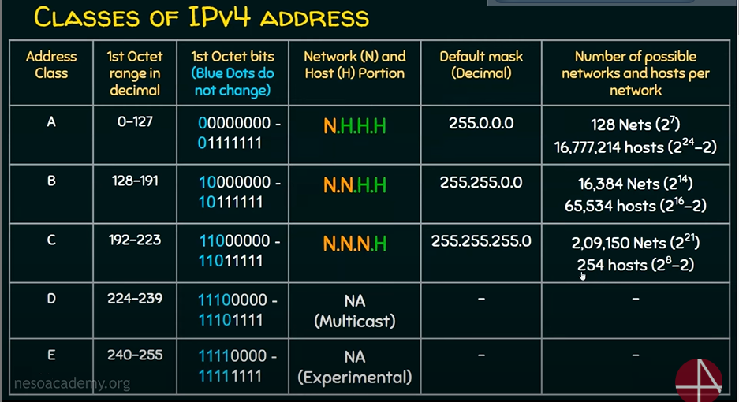

## Drawback of classfull addressing:

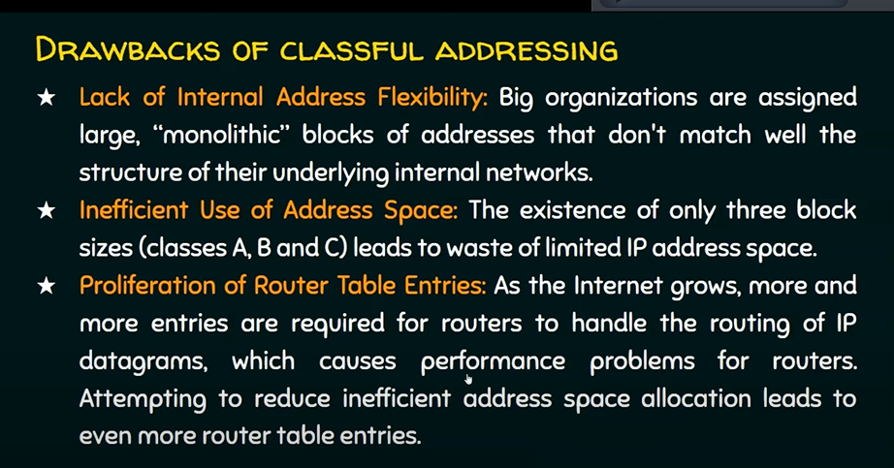

## ClassLess addressing:

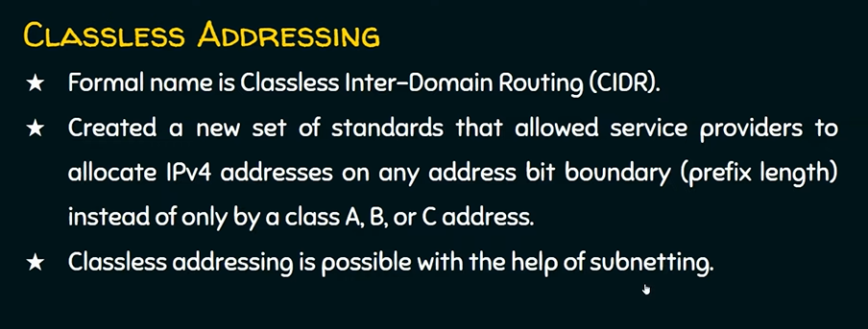

## Subnet Mask:

In a subnet mask there wil be consecutive 1’s and consecutive 0’s.

In first there will be consecutive 1’s 🡪 this bits are used for 🡪Network portion

Last there will be consecutive 0’s 🡪 this bits are used for 🡪Host portion

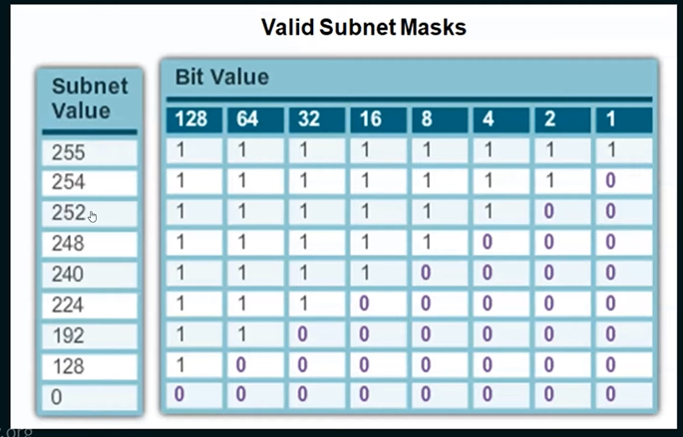

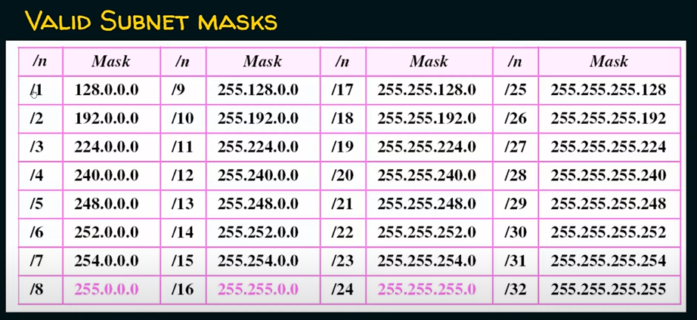

# Fixed Length Subnet Masking (FLSM)

## Subnet Def & Process:

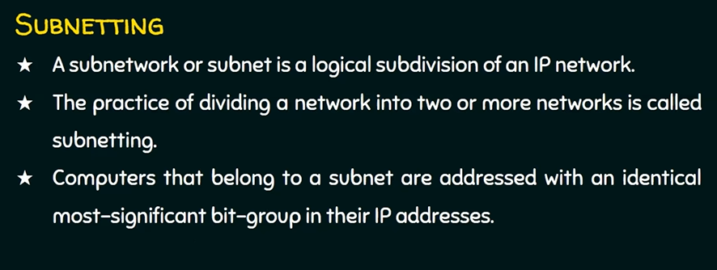

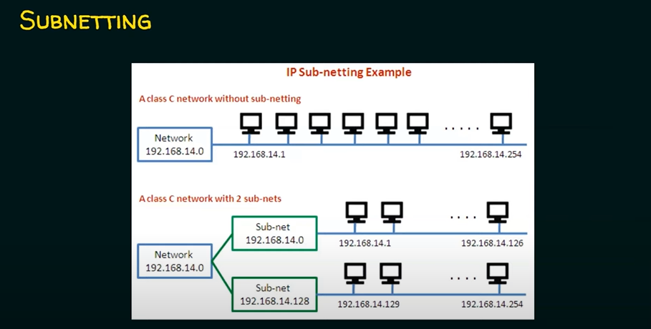

## Steps for Subnetting:

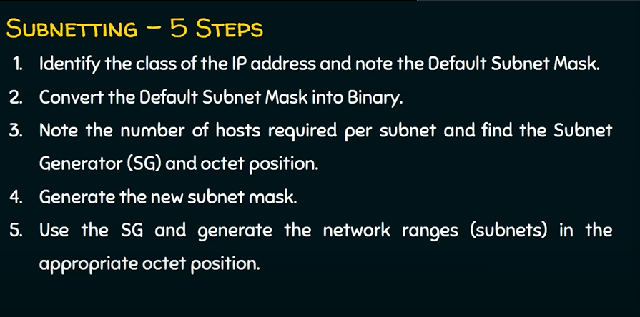

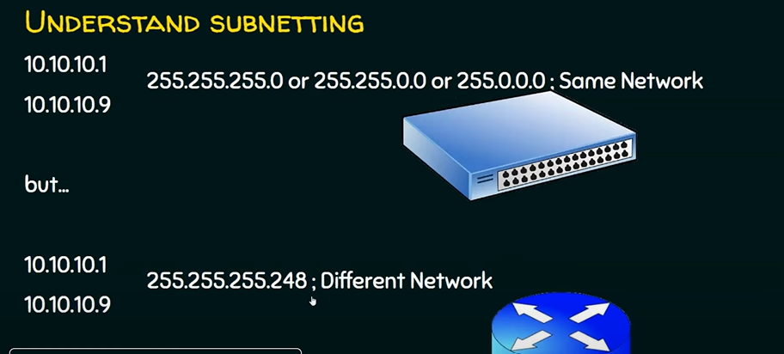

## Problem 1 FLSM:

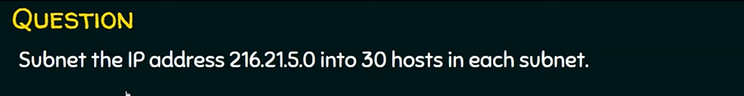

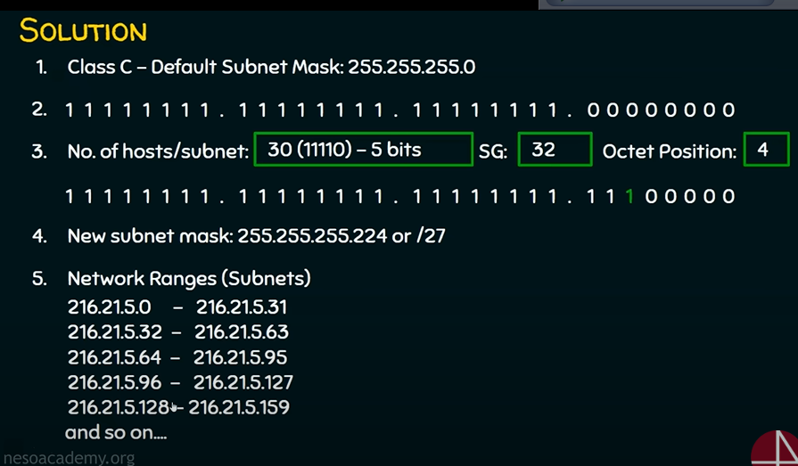

## Problem 2 FLSM for class C:

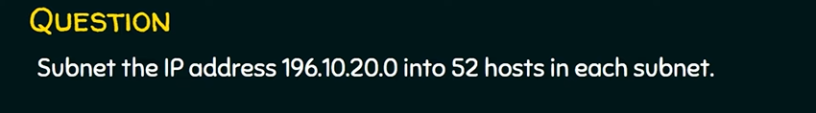

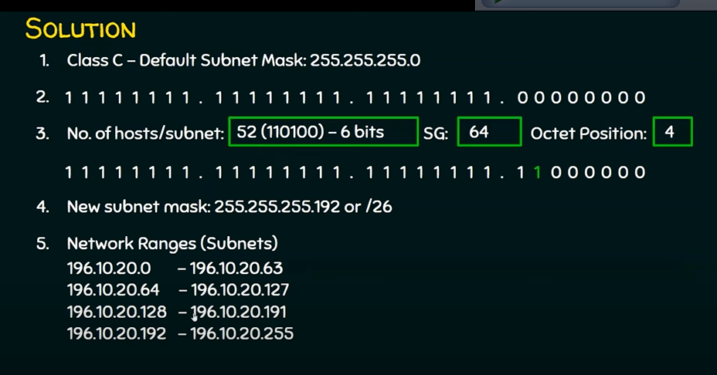

## Problem 2 FLSM for class B:

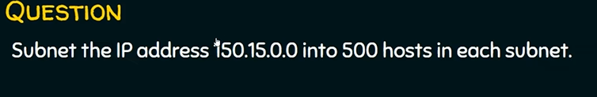

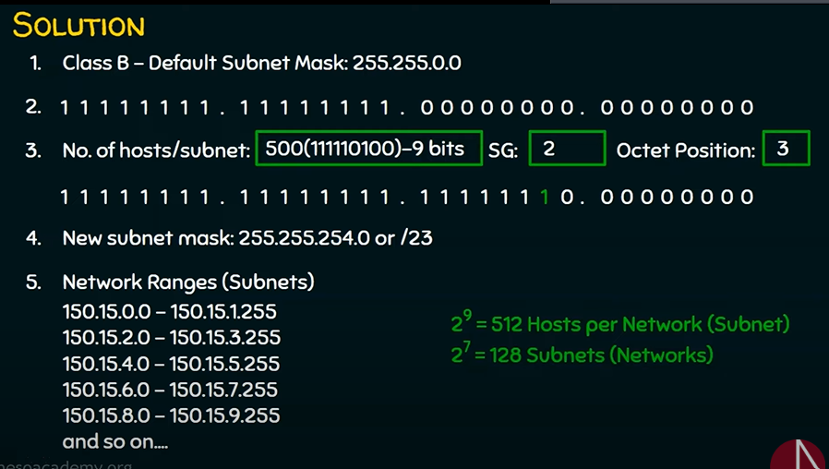

## Problem 3 FLSM for class A:

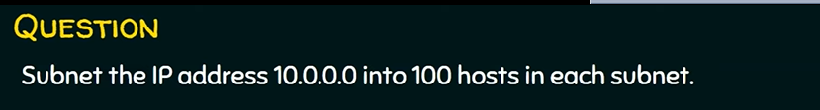

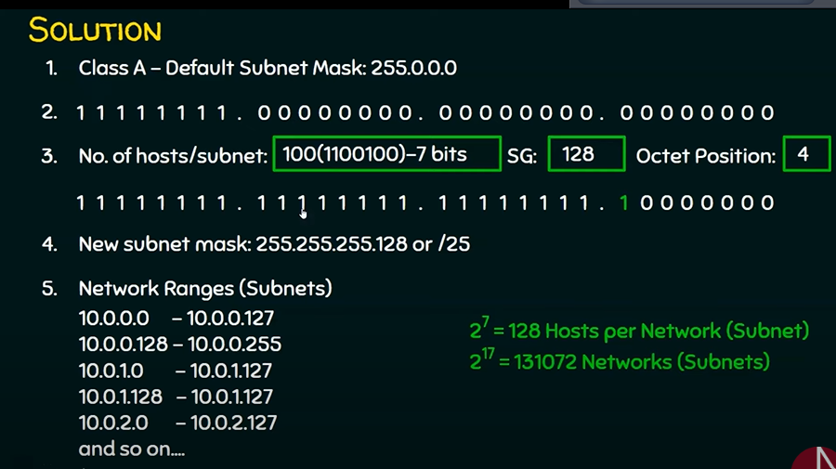

## Network address= IPaddress (Bitwise AND) SubnetMask:

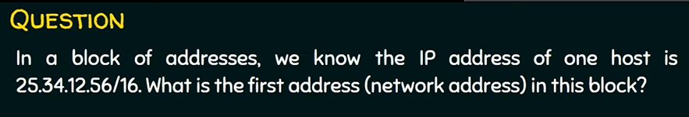

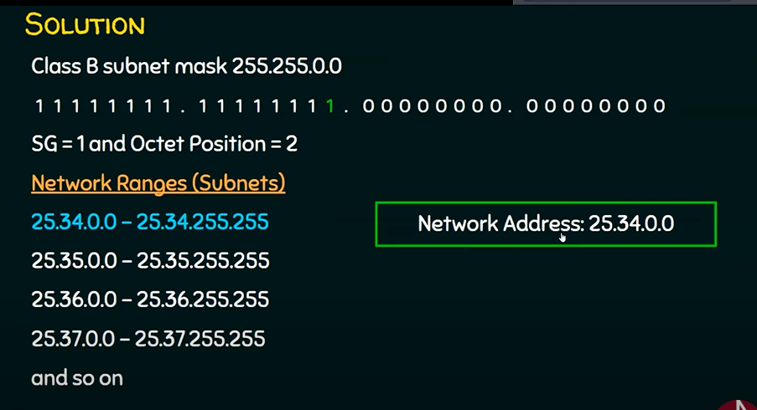

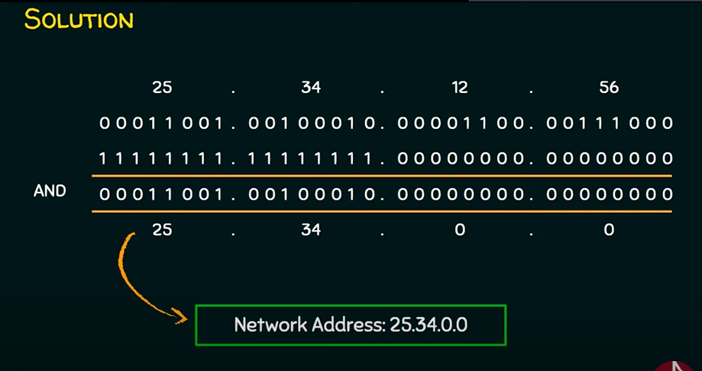

## Broadcast Address= IPaddress (bitwise OR) (1’s complement of SubnetMask)

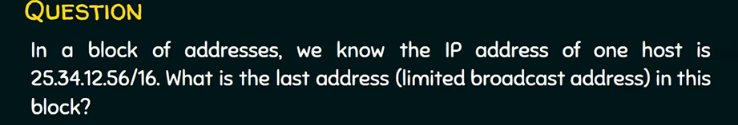

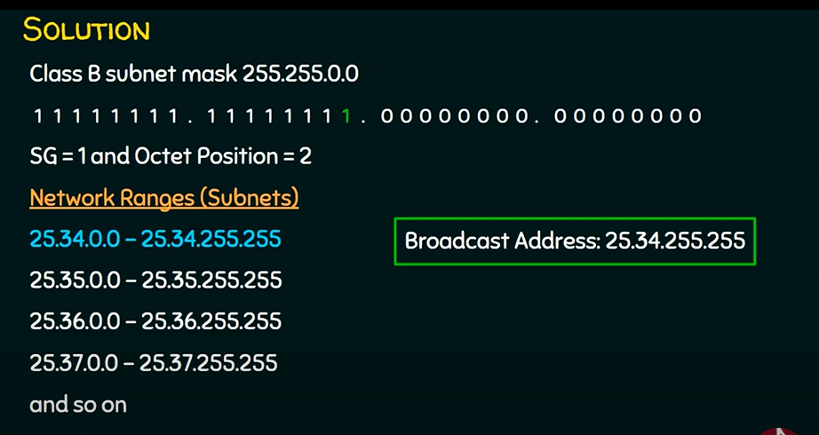

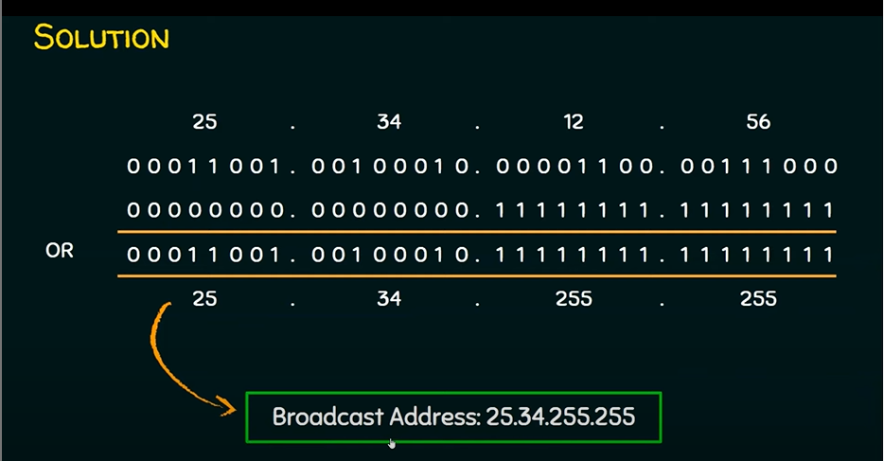

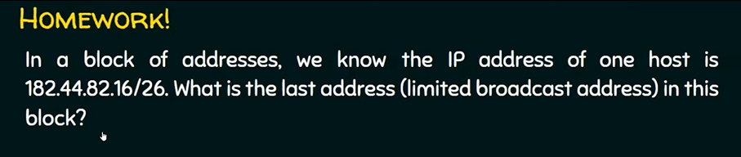

## Subnetting problem 8: no of subnet given , subnet mask=?

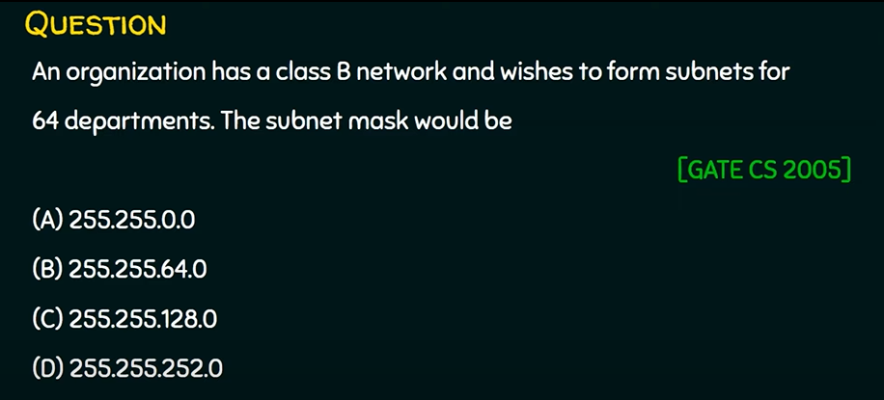

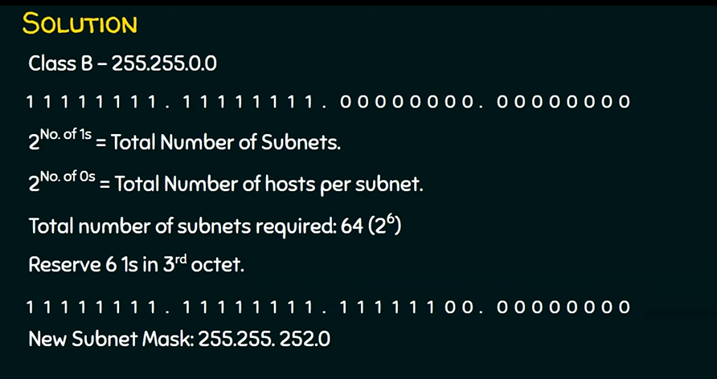

## Subnetting problem 9: subnet mask given, max host/subnet =?

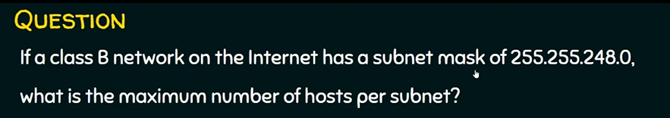

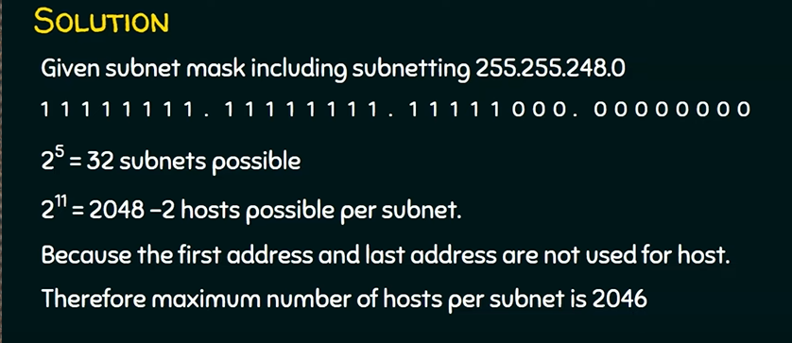

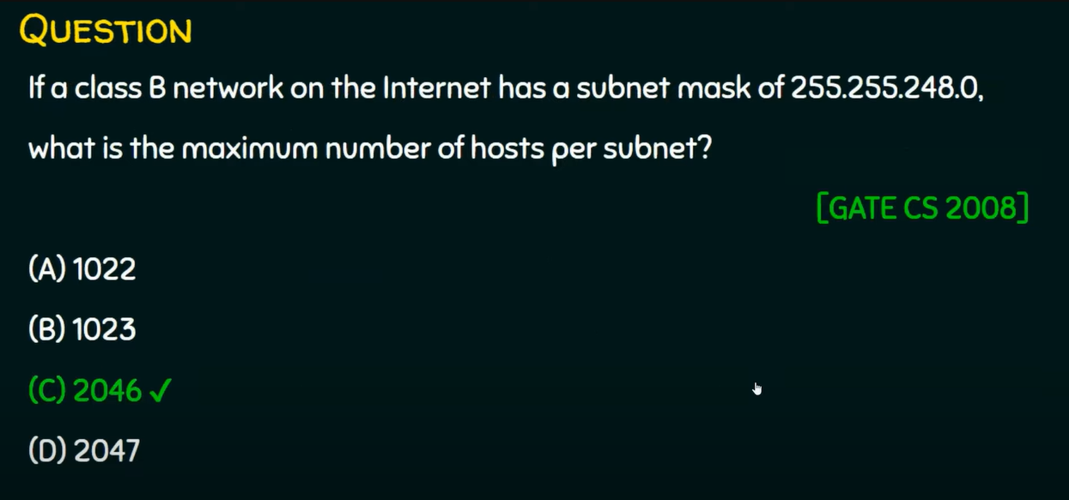

## Problem 10: Subnet Number given, no subnet & hosts =?

### New RCF 1878 convension:

### No of subnet = **2^**(no of **Subnet Bits** in Subnet Mask)

### No of IP addresses = **2^**(no of **0’s** in Subnet Mask)

### No of IP Hosts = **2^**(no of **0’s** in Subnet Mask) **-2**

### 1st IP: network address🡪 all Host bit= 0 ,

### Last IP: Broadcast address🡪all Host bit= 1

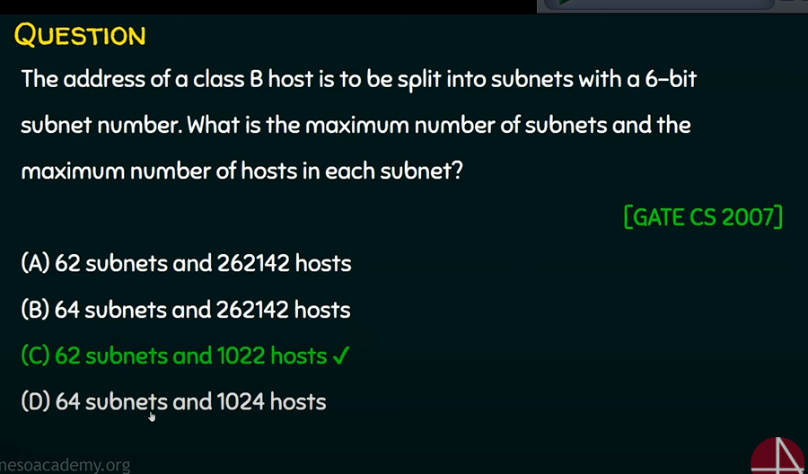

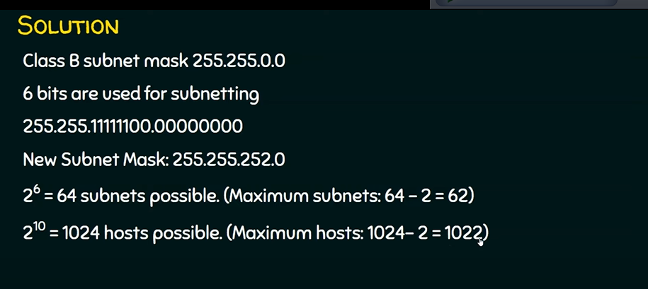

**RFC 950 (Old Convention 🡪 substract 2), Subnets = 62 and**

**\*\*\*\*\*\*RFC 1878 (New Convention), Subnets = 64 \*\*\*\*\*\***

----------------------------------------------------------------------------------------------------------------------------------

# ClassFul FLSM: IP address waste.

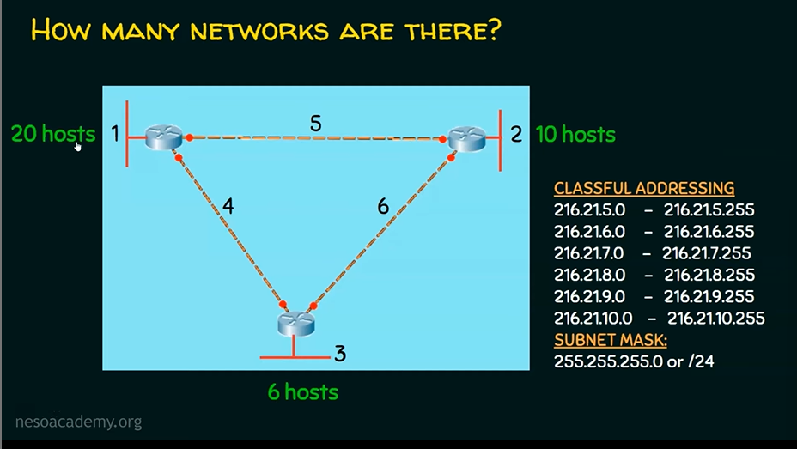

# Class Less Addressing FLSM: wastage of IP address minimum.

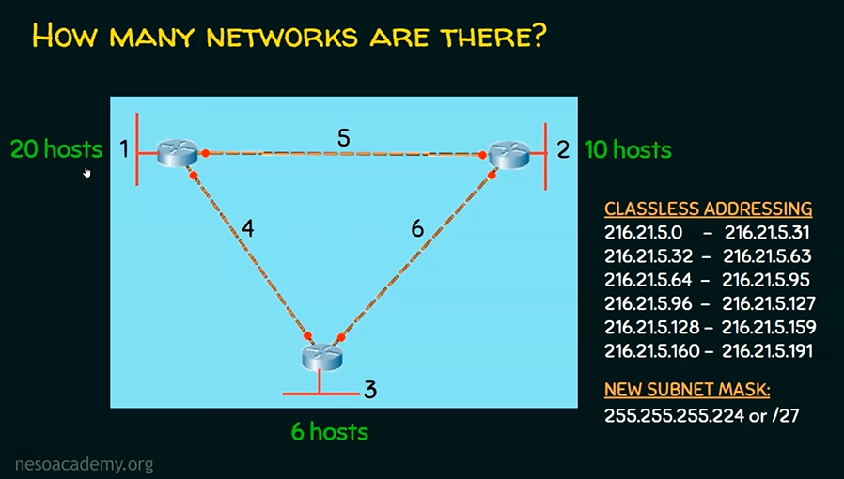

# ***** Variable Length Subnet Masking:

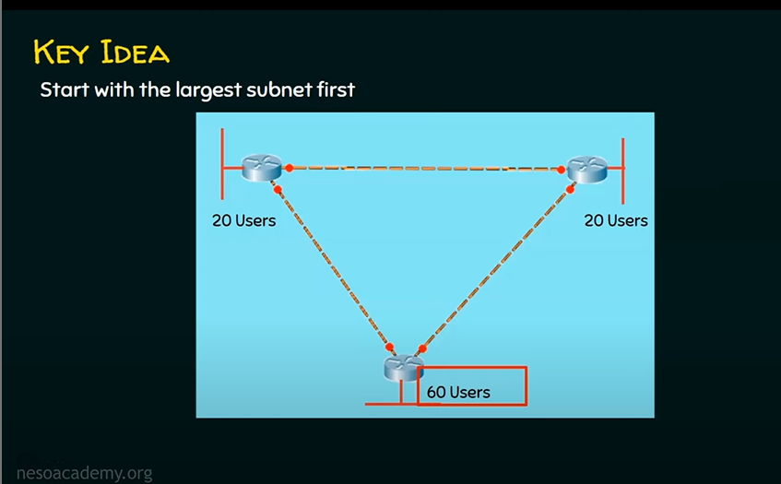

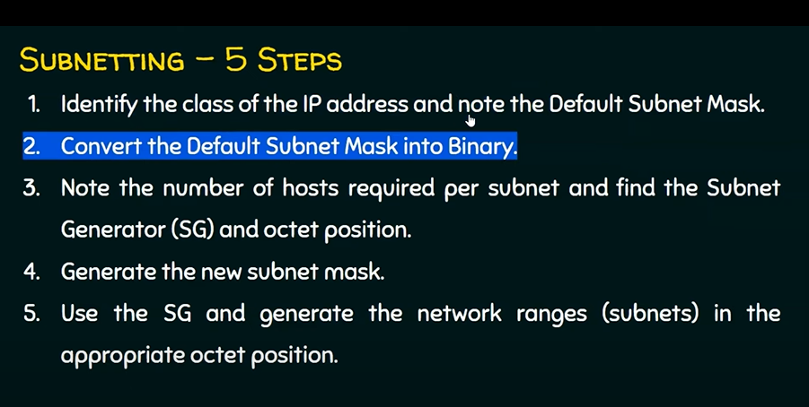

## Problem 1:

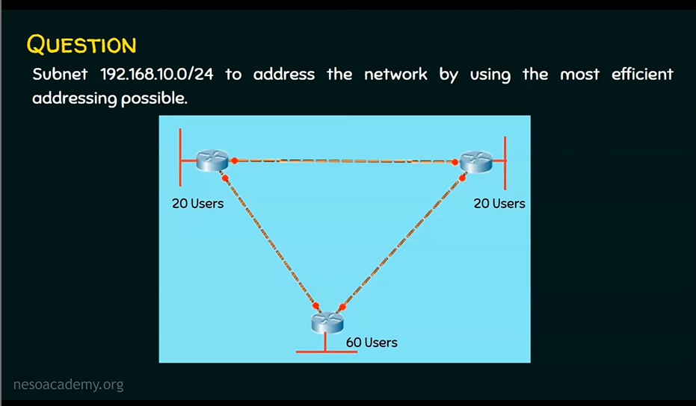

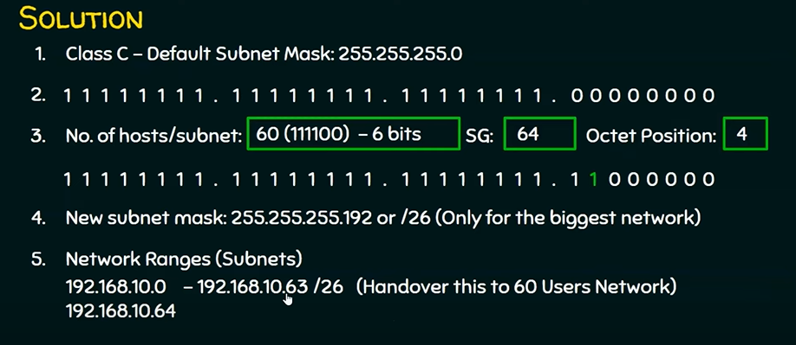

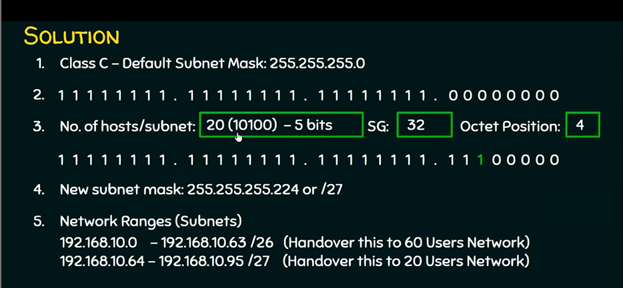

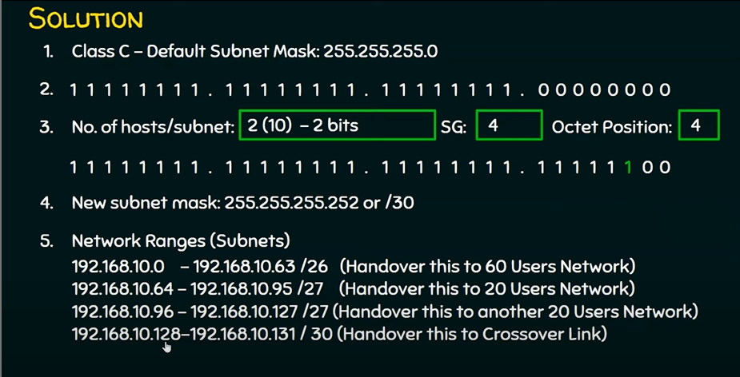

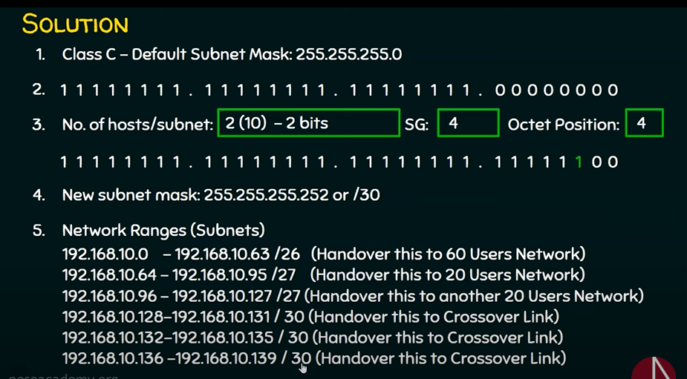

### Get Network address of each Subnet SG=? & Octet Pos=?:

In Given IP 🡪 in SG’s octet🡪 add (SG) Subnet Generator for this subnet

### Subnet Generator = **Rightmost 1’s** position value in it’s octet (in Subnet Mask)

### **K= ( log2( No.Hosts + 1 ) )MOD 8**

### **SG = 2^( k ) 🡪** Position value of last 1 in subnet mask

### Value_in_Octet_pos + 0 --> Network Address ,

### Value_in_Octet_pos + 2^k -1 -->BroadCast Address ,

### 2^k -->IP address possible in this subnet

(2^k) -2 -->usable ip address / host possible

### Octet position of SG = In which octet Rightmost 1 is located in Subnet Mask

Given IP : 192.168.10.0

**For 60 users: SG = 64 Octet pos= 4th**

N/W address 192.168.10.**0** 🡪for 60 users (**largest** host)&

Broadcast Address: 192.168.10.63 --> 4th octet value + (SG -1)

In 4th octet : 0**+64**=64 --> 4th octet value + SG

192.168.10.**64** 🡪for 20 users (**next** largest host)

**For 20 users: SG = 32 Octet pos=4th**

In 4th octet : 64**+32** =96

192.168.10.**96** 🡪 for 20 users (next largest host)

**For 20 users: SG = 32 Octet pos=4th**

In 4th octet : 96**+32** =128

192.168.10.**128**🡪 for 2 switch network (next largest host)

### Answer:

|  |  |  |
| --- | --- | --- |
| Subnet’s number of hosts | Network address | Broadcast address |
| **60**  K = log2(60+1) = 6,  SG= 2^6= 64, octet pos of sg=4th | 192.168.10.**0** | 192.168.10.**63**  **--> 0+64-1**  **=NetworkAddress of nextSubnet -1** |
| **20**  SG= 32, octet pos of SG= 4th | 192.168.10.**64**  **--> 0+64= 64**  **--> 4th octet’s N/W address value of previous subnet + SG of previous subnet** | 192.168.10.**95**  **--> 64+32-1 = 95**  **--> 4th octet’s N/W address value of Current subnet + SG Current Subnet -1** |
| **20**  SG= 32, Octet= 4th | 192.168.10.**96**  **-->64 + 32=96** | 192.168.10.**127**  **-->96+32-1= 127** |

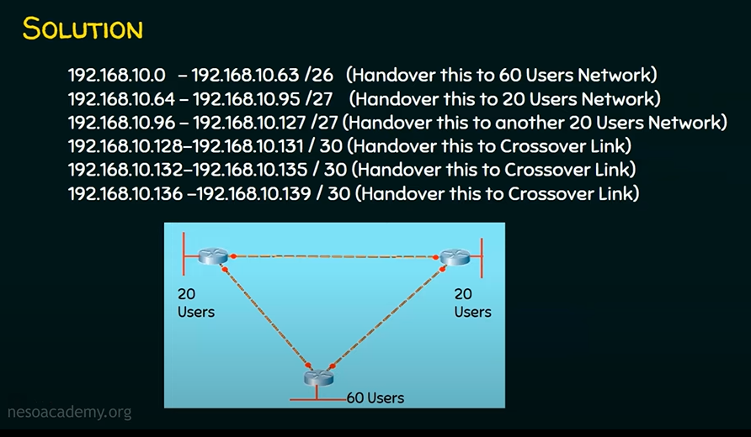

## Problem 2: Variable Length Subnet Masking

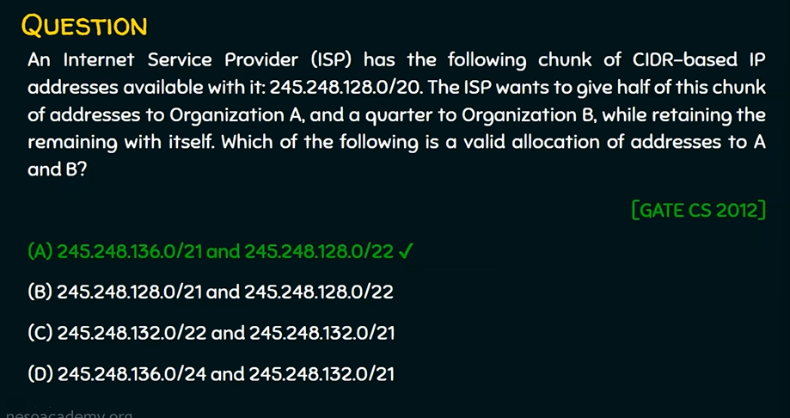

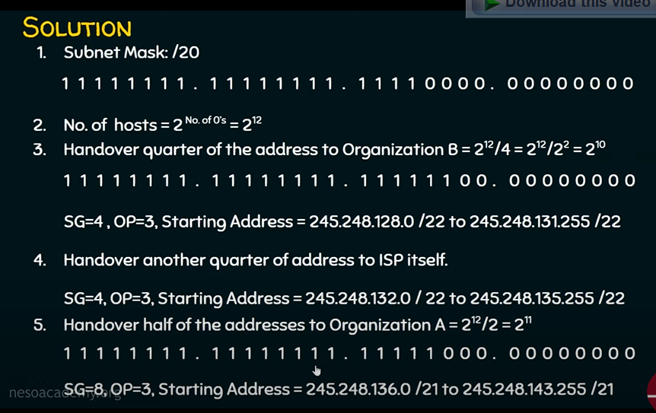

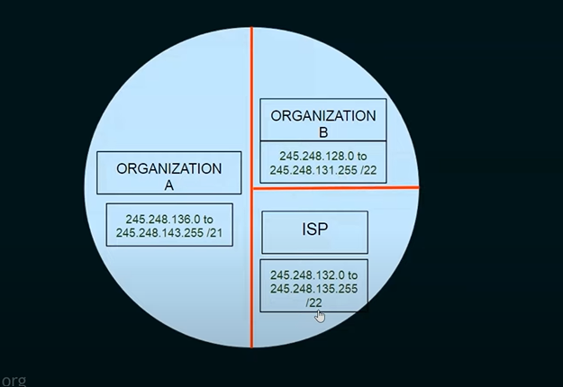

# Open Systems Interconnection (OSI):

## Osi layers

ChatGPT

The OSI (Open Systems Interconnection) model consists of **seven layers** that **define** the functions and interactions of network protocols and devices. These layers are a conceptual framework used to understand and standardize networking processes. From the bottom (Layer 1) to the top (Layer 7), the OSI layers are as follows:

1. **Physical Layer (Layer 1):**
   * Deals with the **physical medium** and **transmission of raw bits** over a physical connection.
   * It includes **specifications** for **cables, connectors,** and **network interface cards.**
   * Examples of devices: **Hubs, network cables, repeaters**.
2. **Data Link Layer (Layer 2):**
   * Responsible for creating a **reliable link** between **two directly connected nodes**.
   * It handles error **detection**, **flow** control, and **framing** of data for transmission.
   * Examples of devices: **Ethernet switches**, network **interface cards**.
3. **Network Layer (Layer 3):**
   * Focuses on routing and addressing, allowing data to be **routed between different networks.**
   * It **determines** the **best path for data packets** to reach their destination.
   * Examples of devices: **Routers**, Layer **3 switches**.
4. **Transport Layer (Layer 4):**
   * Ensures **end-to-end** communication between **devices**.
   * Manages **data flow, error checking**, and provides reliability through mechanisms like TCP (Transmission Control Protocol) and UDP (User Datagram Protocol).
   * Examples of devices: None; it's implemented in software.
5. **Session Layer (Layer 5):**
   * Manages sessions, or connections, between devices.
   * It **establishes, maintains, and terminates** connections, including **managing** **synchro**nization and **checkpointing.**
   * Examples of devices: None; it's implemented in **software**.
6. **Presentation Layer (Layer 6):**
   * Handles data translation, encryption, and compression for the application layer.
   * It ensures that data from the application layer is properly formatted for transmission and reception.
   * Examples of devices: None; it's implemented in software.
7. **Application Layer (Layer 7):**
   * The **topmost** layer that **interacts** directly with the **end-user or application.**
   * Provides various **network services**, such as **file transfer, email, and remote access**.
   * Examples of devices: Web browsers, email clients, and other application software.

Understanding these layers helps in troubleshooting, designing, and analyzing network communications, as each layer performs specific functions and interacts with adjacent layers to ensure reliable and efficient data transmission.

Top of Form

## diffrence between hub,switch,gateway and router

ChatGPT

Hubs, switches, gateways, and routers are all devices used in computer networking, but they serve different functions and operate at different layers of the OSI model. Here are the key differences between them:

1. Hub:
   * Operates at the physical layer (Layer 1) of the OSI model.
   * Essentially a **multi-port repeater**; it receives data on one port and sends it to all other ports.
   * Does **not** have any **intelligence** to determine the **destination** of the data, resulting in network **congestion** and potential **collisions**.
   * Rarely used in modern networks because it leads to inefficiency and increased network traffic.
2. Switch:
   * Operates at the data link layer (Layer 2) of the OSI model.
   * Uses **MAC addresses** to determine the **destination of data packets** and sends them only to the **port** where the **destination device is located**.
   * More intelligent and efficient than a hub, as it reduces network **congestion** and minimizes collisions.
   * Commonly used in local area networks (LANs) to connect devices.
3. Gateway:
   * A **device or software** that connects two different networks with different protocols or technologies.
   * Acts as a bridge between networks to facilitate communication between them.
   * Can perform protocol translation and handle different network topologies.
   * For example, a network gateway can connect a local network to the internet, translating between the **local** network's **internal addressing** and **external internet addressing**.
4. Router:
   * Operates at the network layer (Layer 3) of the OSI model.
   * Determines the best path for data to travel between different networks **based on IP** addresses.
   * Provides **network addressing, routing,** and **NAT** (Network Address Translation) capabilities.
   * Enables communication between devices on **different IP subnets or networks**.
   * Typically used in wide area networks (WANs) and on the internet to direct traffic between different networks.

In summary, hubs and switches are devices used to connect devices within a local network, with switches being more intelligent and efficient. Gateways are used to bridge different networks with varying protocols or technologies, while routers are used to direct traffic between different IP networks, making them essential for connecting devices to the internet and wide area networks.

Top of Form